Parents,

In order to allow your student(s) to stay safe and productive online within the District’s web based resources we are now allowing the option for students to change their own passwords through the Student Portal.

All students now have a ‘Student Password Change’ tile in their portal. It can be found in the top ‘Default’ row on the portal home page. It looks like this:
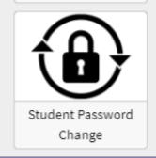
Any student may click on this tile to easily change their password to a new password that they choose. If a teacher has provided a password to students and/or parents, it is recommended that the password be changed using this new portal tile. For security reasons, it is always best that each student create and use a unique password that only the student and/or parent knows.

Please click here for step-by-step directions on how your child can change their password.

NOTE: If/when a student forgets his/her password, the teacher can reset it back to the default password via the ‘Student Password Reset’ tile in the portal.

